# COMSATS University Islamabad, Abbottabad Campus

**Department of Computer Science**



Data Structures & Algorithms Class: BSE- 3 A

NAME : EHSANULLAH

REGISTRATION Number : CIIT/FA17-BSE-024/ATD

Submitted To : Ma’am Ayesha Jadoon

LAB Task : #8

Topic : Queue using Array and Linked List

Programming Exercises

Date OF Sub :

Queue using Array and Linked List Programming Exercises

1. Write a Java program to implement the queue using array?

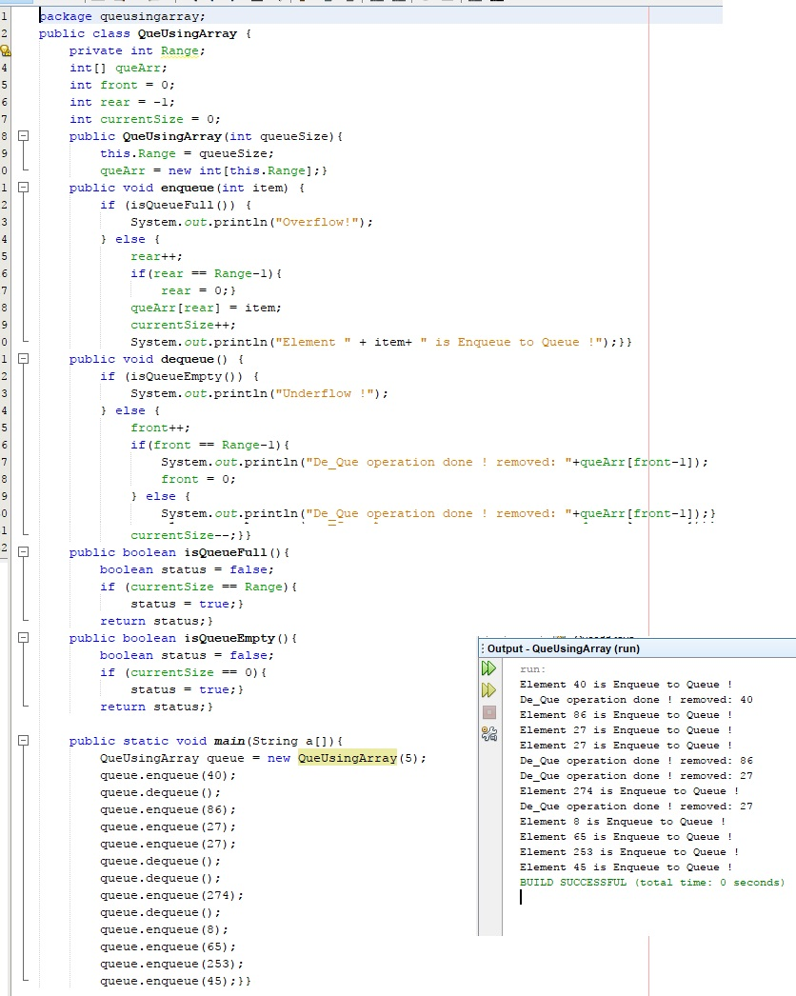

1. Write a Java program to implement the queue using Linked list?

public class qfunctions {

qnode front, rear;

int size;

void enqueue(int d) {

size++;

qnode newq = new qnode();

newq.data=d;

if (rear == null) {

front = rear = newq; }

else{

rear.next = newq;

rear=rear.next;} }

void print(){

qnode temp=front;

while(temp.next!=null){

System.out.println(temp.data);

temp=temp.next; }

System.out.println(temp.data);}

void deqeue(){

qnode temp=front;

size--;

if (front == null) {

front = rear = null; }

else{

temp= front.next;

front=temp;}}

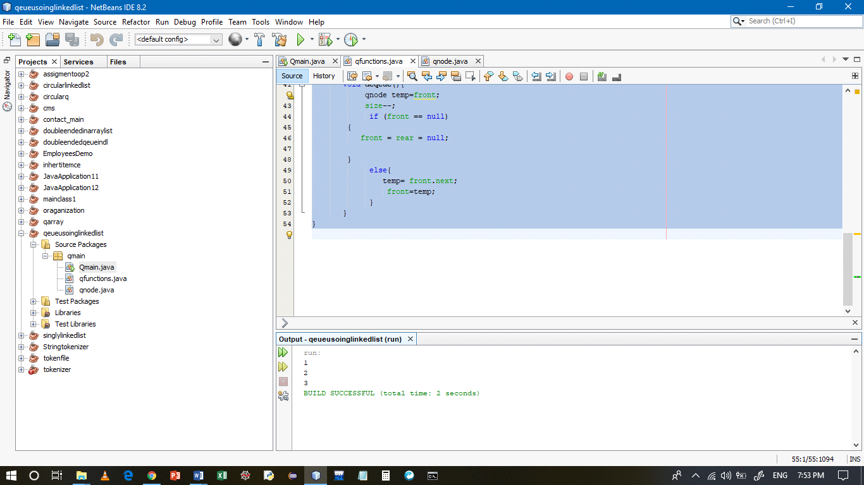

1. Creating a Queue and performing basic operations like Enqueue and Dequeue?
2. Write a Java program to implement the Circular queue?

package circularque;

public class f {

node first=null;

node last=null;

int x=0;

public void insertFirst(int x){

node newNode=new node();

x++;

newNode.data=x;

newNode.next=null;

if(first==null)

first= last=newNode;

else if(c>=5){

last.next=newNode;

newNode.next=first.next;}

else{

first.pre=newNode;

newNode.next=first;

first=newNode;}

public void displayall(){

int h=0;

node current=first;

while(i!=c){

current.displayNode();

current=current.next;

i++;}}

} 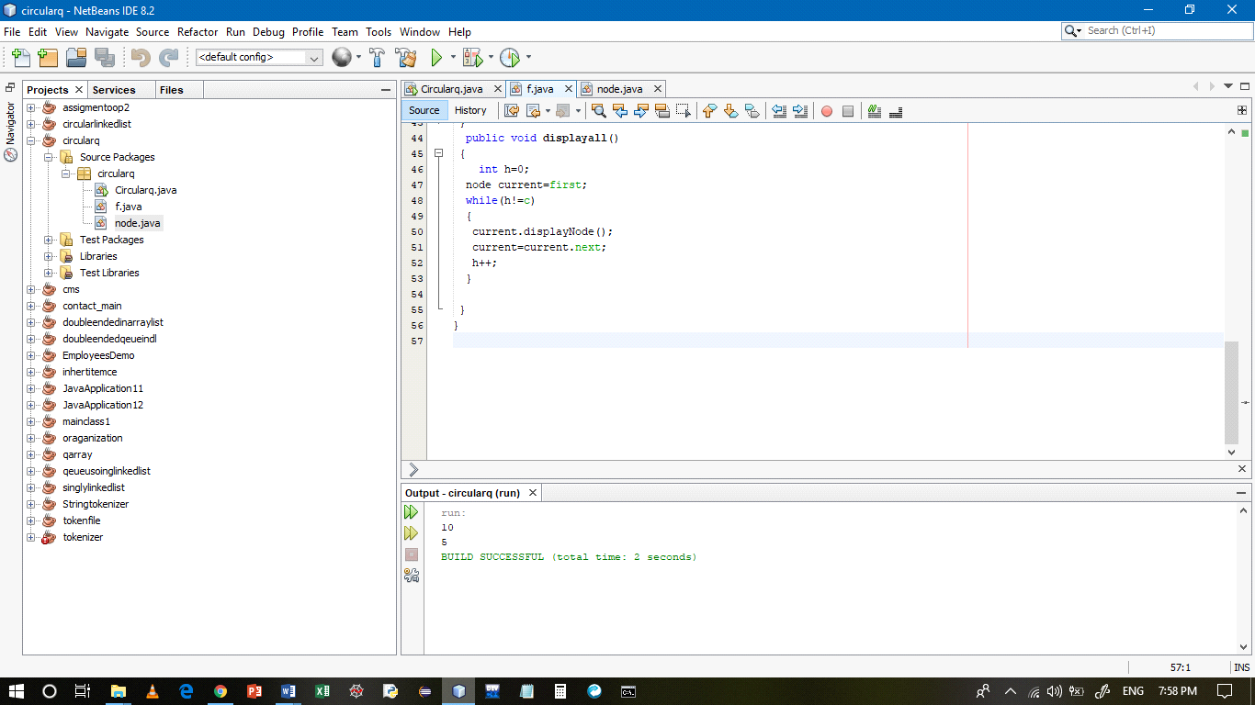

1. Write a Java program to implement the priority queue?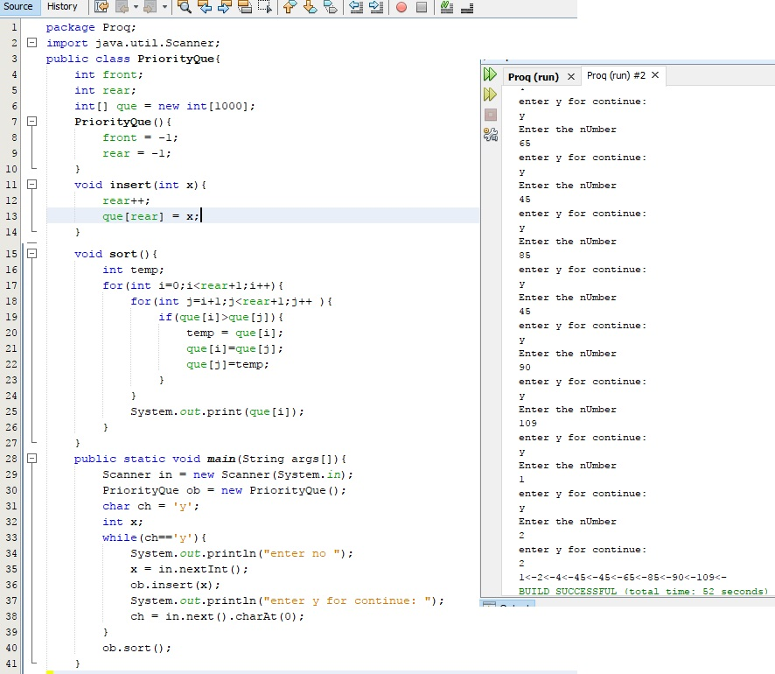
2. Write a Java program to implement the Deque?
3. package dequsingdl{
4. public class f {

node first=null;

1. node last=null;
2. public void insertFirst(int x){
3. node newNode=new node();
4. newNode.data=x;
5. newNode.next=null;
6. if(first==null)
7. last=newNode;
8. else
9. first.pre=newNode;
10. newNode.next=first;
11. first=newNode;}
12. public void insertLast(int x){
13. node newNode=new node();
14. newNode.data=x;
15. newNode.next=null;
16. if(first==null)
17. first=newNode;
18. else{
19. last.next=newNode;
20. newNode.pre=last;}
21. last=newNode;}
22. public void deleteFirst(){
23. if(first.next==null)
24. last=null;
25. else
26. first.next.pre=null;
27. first=first.next;}
28. public void deleteLast(){
29. if(first.next==null)
30. first=null;else
31. last.pre.next=null;
32. last=last.pre;}
33. public void displayall(){
34. node current=first;
35. while(current!=null){
36. current.displayNode();
37. current=current.next;}}

} 